West Hull Ladies
RRC

November
Newsletter

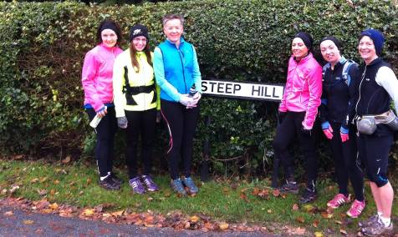

Rudo

Rudolph’s Around the Corner ...

WEST HULL LADIES RRC
COMMITTEE MEETING

West Hull Ladies Committee Meeting 05/11/2012

Attendees:- Amanda Dean, Verity Pick, Debbie Watson, Sandra Holdsworth and Louise Ede

Minutes of Meeting Monday 5th November 2012

Present – Ann, Amanda, Debbie, Sandra, Louise

- Apologies were received from Annette and Verity
- Amanda stated that the Club would pay the £280 required for the courses and the other LIRF courses to be funded by HAN.
- Amanda was meeting with Rebecca Senior (HAN) and Gary Sainty on Thursday. She also spoke of an application that could be used on an I pad to assist with gait analysis. It was decided that Amanda would forward this info to Sports therapist Jamie from Body Fixed.
Action – Amanda to contact Jamie - Completed – 6/11/2012
Action – to report back from meeting. – Completed 7/11/2012.
Feedback from meeting as follows -
• The LIRF course applications for Debbie, Sandra, Ann and Verity were handed in with payment. UKA should email the applicants before Christmas with details.
• The CIRF course (Amanda) bursary claim was dealt with. Rebecca will need the club account details and treasurer address.
• It is noted that all five of us will need to complete a CRB application even though we do not allow children at the club without mum.
• Gary is keen to get a register of new club members. His remit is to get more people into sport and if he can show we have increased members this helps his KPIs and thus helps get more money for sport into the area. ACTION Amanda will send information. ACTION Everyone. For the same reason, Gary is asking everyone to register on RunEngland http://www.runengland.info/
• Rebecca said that two workshops would be arranged and asked for ideas. I immediately suggested ‘Sport Nutrition’ and it is possible that this will be arranged for around the middle of the beginner runners 6 weeks course which we plan to start 4th February. My second suggestion was ‘Injury Avoidance’. However, if you have ideas and preferences for a workshop email Rebecca: RSenior@goodwin-centre.org

- Amanda brought flyer designed by Verity promoting the course and a ‘version b’ edited by Amanda. All agreed it was an excellent joint piece of work – thank you. Discussed the flyer and Amanda was making a couple of amendments and also working on an article for website
Action – Amanda to make leaflet amendments – Changed and passed to Verity 6/11/2012
Action - Amanda to create web page for website. – First draft completed 7/11/2012 http://www.westhullladies.org.uk/run.htm

- Debbie stated that she was still in the process of fully taking over the role of Treasurer and would meet soon with Victoria to complete handover.
- In relation to role of Secretary – Sandra was happy to being the meeting secretary. Louise had made a list of what the role of Secretary entails. She would forward this to Debbie who would endeavour to find a willing volunteer to perform this role.
- Discussed offer of a Boot Camp type training session offered by Chris Hames. Agreed that details would be put on the next newsletter so if any member interested they could contact him direct.
Action – Ann to include details in next newsletter

- Discussed December training session. Agreed that Friday 21st December we would do the “ Avenues Advent Calendar Run ‘ finishing of at Amanda’s for refreshments provided out of club funds.
The run on Wednesday 19th December would include a viewing of Cottingham Christmas Lights.

When Running Isn’t Enough ...
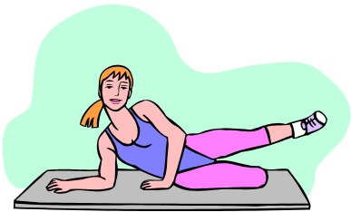
Adapted from: –Shankara Smith on http://www.runandbecome.com

Cross training – why?

Cross training is a great way to ensure that your body is fit, strong and well balanced, the latter being very important in preventing injury and the development of weaknesses as we get older.

What benefits will I get?

Cross training can almost be seen as a cheat’s way to a faster 10k. Instead of basing all your training on pounding the streets (though you still have to do quite a lot of that!), by working and strengthening different muscle groups you’ll find that you fatigue more slowly and your speed will improve faster.

What routine should I do?

If you belong to a gym, book a session with a trainer and they’ll give you a tailored programme suited to your level and needs. Get a follow up session every month or two for variety and to tweak things as you get stronger.

Or, do some of these exercises at home, starting with light weights and small repetitions and building up as you get stronger. Use a little ingenuity – filled water bottles become weights and chairs become balancing tools.

Remember, listen to your body! Adjust the exercise or choose another if it doesn’t feel right, and build up slowly. Alternate arm and leg exercises. If you can, use a mirror to check your posture, and warm up before you start

Arms
- Butterfly wings: lying on a bench or floor, lift weights straight above your chest and open arms out to the side, keeping arms slightly bent. 15x reps.
Legs
- Lunges: step one leg forward and bend your knees until the back knee is almost touching the floor, push back up with your glutes (bum muscles), repeat changing legs. 10x reps each leg.

- Single leg squats: balance back foot on medicine ball or chair, with back leg as straight as you can, hands on hips, squat front leg, keeping hips aligned and stomach firm. 10x reps each leg.

- Step up: onto a bench (or chair) powering with your glutes. Count how many you can do in a minute, changing the lead leg half way.
- Core
Standing feet hip width apart, hold weights at your side, half bend as if going to sit on a chair, then turning palms to face ceiling, stand up, bringing hands to your shoulders. From here turn palms to face the mirror and lift elbows out to the side (arm at right angles), then straighten arms up above your head. Then reverse to starting position. 10x reps.
- Plank: lie face down, with your hands clasped as if in prayer, now push up so your forearms and toes are on the floor, keep your body straight – not sagging in the middle! Hold for a minute, or as close to as you can!

- Lie on the floor with legs and feet pointing to the ceiling. Anchor yourself by holding onto a table leg behind your head, or grip an obliging person’s ankles (arms should not be straight, but bent). Slowly lower your straight legs as far down as you can without straining lower back, repeat 10 times. Then push your feet up as though to tap the ceiling, lifting your hips slightly off the ground, repeat 10 times fast.

Exercises are boring, what other options are there?

Some WHL are cycling – this may mean just dust off that old bike in the garage and take it for a spin at the weekend, or start commuting to work and save your petrol. Other ladies are joining clubs – take a look at Hull Thursday Road Club, or a ladies’ cycling club http://www.sundaygirlsroadclub.co.uk/


Swimming is another sport worth considering – if you want the structure of a club, then try Hull Masters Swimming Club (these are not just elite swimmers) http://hull-masters-swimming-club.org/

Or put them all together and try triathlon! There are all sorts of distances to try, and clubs for all levels of abilities, including Hull and East Yorkshire Triathlon, who are a fairly new and friendly club with their own open water swimming lake in Burstwick.

Alternatively, you may be interested in this -

Your own personal trainer ... !

“My name is Chris Hames, I am the chief Physical Training Instructor and the Defense School of Transport Gymnasium here at Leconfield and founder of the Beverley Boot Camp and Body and Mind Fitness.

I have been in the Royal Army Physical Training Corps for 16 years now and I am approaching my last year, I have recently returned from Afghanistan where I implemented the basic compound body movement training to ensure that over 1000 soldiers were ready for infantry front line duties, this was very effective and I am now keen to influence local sports clubs and individuals about the effectiveness of different training routines included in their programme.”

Chris Hames

Tel. 01964 502036
Mob. 07824 768 069

www.bodyandmind-fitness.co.uk

(If ladies know of other clubs or activities that may be of interest, then please pass this on and I’ll put it in the next newsletter - Ann)

Haltemprice 10k

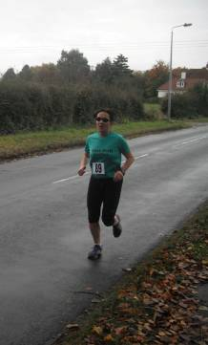
Debbie

Debbie ran so fast that her memory of the race was just a blur, therefore she was unable to provide a race report. Thanks go, therefore, to Sandra, who using her ultra speed camera was able to capture a couple of glimpses as she sped by ... !
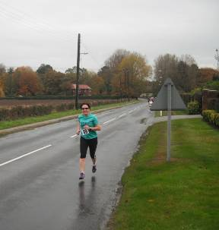

Leicester Half Marathon

Lisa

A couple of weeks before the race my friend pulled out and I also found out I’d have to run without music, so I’d be running alone and I’d have no idea of my speed (I should really get a watch).

Sunday morning was chilly; there was even a thin layer of frost on the windscreen. So I made sure I was warm enough when I set off but it meant that by mile 3 I was too warm, I had to uncover my ears, take my gloves off and roll up my sleeves.

One good thing about being able to hear was that I caught snippets of conversations. I found out I’d got to 5 miles in 46 minutes which was good. I managed to keep up this pace until about 7 miles when I started to slow a little. It was at this point when people who were aiming for 2 hours started to get away and I didn’t have enough to keep up with them.

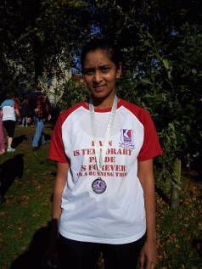
At 10 miles I was mentally talking to myself to keep me going, knowing that I only had 3 miles to go (a Parkrun or 3-mile surprise) made it that little bit easier. With just over a mile to go a man overtook me on an uphill bit and told me to “keep going, I’m using you to pace myself”. I found this strange as I had no idea of my pace at that stage. I had a quick glance up at clock tower as I ran through the city centre and saw it was about 2 hours and I had just over a mile to go, the uphill mile. The last mile was tough but I kept thinking of all the Humber bridge hill training, I was also helped by the lovely firemen who told me it was only another 400 metres to the finish.

It was nice spotting my family coming up to the finish line, just as I started my sprint. The clock was at 2 hours 13 when I crossed and my actual time was 2 hours 11 minutes 16 seconds, so a PB by 9 minutes. Then it was through the funnel to collect a well-deserved banana, bottle of water, medal and t-shirt. I love the t-shirt, it says “pain is temporary, pride is forever (it’s a running thing)” on it.

I didn’t get a chance to ask beforehand but if anyone would like to sponsor me the link is www.justgiving.com/LisaLeicHM it’s for Heart Link a local Leicester charity that supports families and children suffering from heart defects.
Bridlington Half Marathon

Nicola
I made a wee note of my Bridlington half marathon experience:

This was my second year of doing the Brid half, I only decided a couple of weeks prior that I was going to do it again. I'd not ran 13 miles since doing the Brass Monkey half marathon in January so I took a gel with me to have at the 10 ish mile mark... This gel fell out of my pocket within about 200 yards of the race starting, no chance of picking it up owing to the stampede of runners behind me! I also believed that I must have repressed memories of all the hills as I seemed to be constantly running up hill. It was foggy and cool which I quite enjoyed running in.

Overall the run went quite well and thanks to the speed work and running that I've done with the club I knocked 7 minutes off last year’s time (2:13).

Nicola

Scarborough 10k

Jill

Me and Zoe were quite pleased to actually get to the start for Scarborough as husband Kev, who has Parkinsons disease has been a bit ill this week, so we were not sure that we would be able to go. Fortunately he was feeling a bit better so we found ourselves in windy Scarborough on Sunday morning.

At the start we saw Helen, Geri and Susan, so that was nice. I must admit, this is the third time that I have run Scarborough, and it never seems to get any easier. I always think of it as being quite flat, but there are some sneaky 'hills', some awkward cobbles, a bit of a vicious wind as you come around the headland and it seems to go on for ever!

I think we all found it really hard, but I was pleased, and surprised, that I managed a new PB.

The best bit was having a nice cup of tea and a slice of carrot cake with Zoe, Geri and Susan after the event...good tee shirt too!
Deep Dale Dash 10k

Sandra

I saw that this was a relatively new race only having been held for the past 2 years. With it being so close to home I thought that it would be good to run and support a local club. The course had some really good reports and was described as ‘undulating’.

So last Sunday I crossed the Humber on a dry but bitterly cold morning with the sun doing its best to make an appearance.

The start was outside the local Comprehensive school and the first 200m was downhill – but after that the course was what I would describe as hilly – not undulating. The first mile was quite hard but then we were out into the countryside, which made it more bearable.

Miles 2-3 was a mixture of up and downhill. Miles 4-5 were hard – just a long drag. I checked my Garmin and saw that I was running well under 7 mph so that gave me a jolt and I tried harder – it was still my slowest mile though.

The mile from 5-6 was downhill and back into the town through a residential area. This was fine until you reached the 6-mile mark and then saw that the last part of the course was a tough uphill – how cruel was that!

At the end we were given a black technical t shirt with long sleeves and a goody bag. Cold drinks and cakes were also available – very yummy.

I can say that I really enjoyed the run - it was hard but enjoyable and a bit of a challenge. The Marshalls were very supportive and plentiful. The atmosphere was just so good without me being able to put my finger on quite why. Maybe it was because most of the runners were local from both sides of the Humber and the limit was 320 so quite small in many ways.

Next year this will definitely be on my list and I would urge you to do it – I am sure that it will be harder to get a place as its reputation as a great run increases.
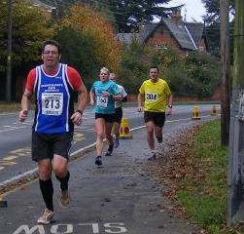
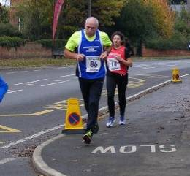

Rudolph Recce

Verity

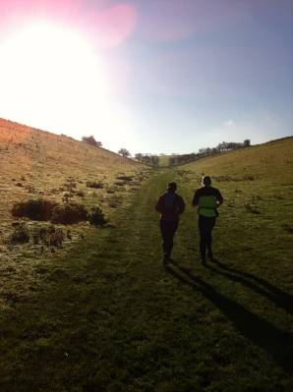
Just 3 of us for the run this morning: Sandra, me & Simon. It was another beautiful morning for running (see attached photos). The tracks were still muddy and the hills were tough but the sunshine helped a lot! Looking forward to the route from North Cave next week.

Racing and Running Events

Date | Event | Distance | Fee | Entry / website
December
1st 8.30 | Rudolph Romp | 24 miles | £9 | Entry form
2nd 9.30 | Percy Pud –Sheffield | 10k | £14 | Entry form
26th 10.30 | Boxing Day 10k | 10k | £10 /£11 on the day | Download entry form from website
January 2013
1st 11.15 | Cleethorpes New Year’s Day 10k | 10k | £9 | Entry form
5th 8.30 | Scarborough Rock | 16/24 miles | £7 | Entry form
20th 10.00 | Brass Monkey | ½ marathon | - | Full
27th | Ferriby 10 | 10 miles | £11 | Entry form
February 2013
24th 11.00 | Snake Lane 10 | 10 Miles | £12.50 | Closed!
March 2013
17th 10.00 | East Hull 20 | 20 miles | £18 | Entry form
April 2013
17th 10.00 | Hornsea Third | 8.74 | £10 | Entry form
15th 8.00 | The Woldsman | 50 miles | £17 | Entry form email to eyldwa_entries@btinternet.com

East Hull Harriers Winter League
East Hull Harriers would like to invite WHL club members who would like to run in any of the East Hull Harriers 2012/2013 winter league. You will not feature in the league itself but can take part in the races
There is no entry fee just turn up on the day
Any further information ring John Baker on (01482) 824648.
Saturday 15th December 2012 – Christmas Handicap
Distance: 6 miles (staggered start)
If you intend to run in the staggered start races let the organisers know one week before race for handicap purposes
Start Time: 2.10pm Terrain: All cross country Venue: EHH Clubhouse,
Sunday 13th January 2013 – Beverley Westwood – EHH Club Championship
Distance (Men): 6.6 miles
Distance (women): 3.3 miles
Start Time: 10am Terrain: Mostly grass
Venue: Newbald Road, Beverley Westwood
Saturday 16th February 2013 – Riverbank Run
Distance: 6 miles (staggered start)
Start Time: 2.10pm Terrain: Riverbank Footpaths
Venue: Ennerdale Leisure Centre, Sutton Road, Hull
Friday 29th March 2013 – Good Friday Hill Run
Distance: 7 miles
Start Time: 10am Terrain: Footpaths & Hills Venue: Elloughton
Thursday 11th April 2013 – Paull Run
Distance: 5.7 miles
Start Time: 7pm Terrain: Riverbank Footpaths Venue: Paull Lighthouse
Check EHH website for all up to date information: www.easthullharriers.com


Try a Tri?

Sprint Triathlon - 9th May
Burstwick - Open water swim 750m (see picture), 20k bike, 5k run – Facebook link

Olympic Distance - 13th July
Ripon – have a look at the promo video

Children’s Triathlon – 8th June
Rother Valley - 150 metres swim / 4km cycle / 1.2k run
Check out the website here – this is a whole weekend of triathlon, including a ladies only sprint event

Keep checking the website for new races and updates: www.westhullladies.org.uk/races.htm Verity, Racing Officer

NOTE: Club Vests must be worn at any races you enter
under the West Hull Ladies running club name.

And finally ...

Who said what ...

Here are some quotes, and some names – see if you can work out who said what ...

"Running is the greatest metaphor for life, because you get out of it what you put into it."
"Ask yourself: 'Can I give more?'. The answer is usually: 'Yes'."

"We run, not because we think it is doing us good, but because we enjoy it and cannot help ourselves...The more restricted our society and work become, the more necessary it will be to find some outlet for this craving for freedom. No one can say, 'You must not run faster than this, or jump higher than that.' The human spirit is indomitable."

"Whether you believe you can or believe you can't, you're probably right."

-Henry Ford
-Oprah Winfrey
-Paul Tergat, Kenyan professional marathoner
-Sir Roger Bannister, first to run a sub-4 minute mile

Clubwear
PRICES:
Vest | £16.00 | All items are ordered on request and must  be paid for at time of ordering. To place an  order please get in touch via West  Hull Ladies e-mail and mark your emails  for the attention of Geri.
T- shirt | £16.50
Hoodie | £14.00
Jacket | £32



New Club Jacket available in three sizes: small, extra small, and junior (large fitting). If you would like to purchase one please send a cheque for £32 to Debbie Watson, Treasurer, and state on the back of your cheque your name and that the cheque is for a jacket.

Jo

Running Library

You can borrow any of these books – they are upstairs near the toilets at the end of the corridor
Book List:
- The Runner's Diet (Runners World), Madelyn H. Fernstrom
- Paula My Story So Far, Paula Radcliffe
- The Runner's Handbook, Bob Glover
- The Competitive Runner's Handbook, Bob Glover & Shelly Lynn Glover
- Marathon Running For Mortals, John Bingham

- Lore of Running,

Running Magazines: These are available to borrow by emailing the club website.
Mark your email for the attention of Jo.

